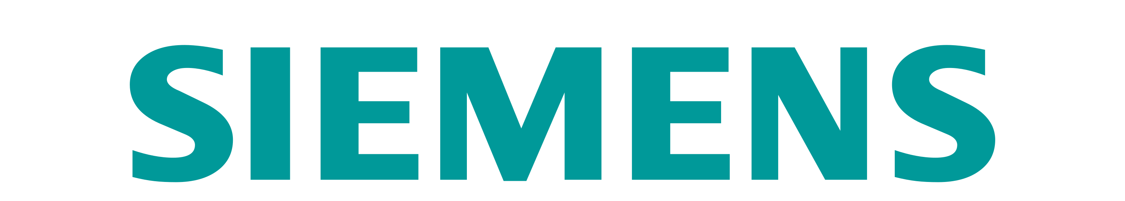


Check list

To LAUNCH A YEARLY NEGOTIATION

This checklist summarizes the actions to conduct before to run negotiations with Buymanager Nego.
Some actions must be done by IT, others by key users or Buymanager admin.
A Gantt planning to review all these actions in a timeline can be provided upon request.
The Supplyframe team remains available to help you through this process.

Please note that some of the documentation below are available in French, you need to click on “Français” on the top right of our Help website.
Action | Explanation | In charge | Status
Update Buymanager release | Make sure to be in the latest Buymanager release for the Nego module  - Link of the latest release : click here, then click on “Download”  - Process to update Buymanager : click here  NB : if it’s a first Nego module installation, it will be done by Supplyframe. | IT
Activate Nego licence | Use the licence file provided by Supplyframe : “202X-XX Nego licence.txt”  Activate licences : Process available here | IT or BM admin
Access to server | - Make sure all users have access to Buymanager Nego : in RDP or directly on their laptop  If RDP, give access to shared folders so users can upload/export data between the server and their laptop | IT
Set up user accounts | Depending on your needs, here is the documentation :  - Create new users : process available here  - For each user, activate the licence “Simplified nego module V4” : process available here  - Set up emails for users : process available here  - Define a password for users : process available here  - Deactivate previous users : process available here  - Disconnect all users : process available here | IT or BM admin
Review plants  (optional) | Only if your company has several plants, and these plants will be considered in your negotiation  Documentation available here | IT or BM admin
Update / create Excel templates | There are up to 4 different templates : RFQ, LOA (award), internal report 1, internal report 2  Please define in Excel the expected templates (colors, titles, format…) and provide them to Supplyframe for set up in Buymanager  A training can be provided upon request (free of charge) to give you autonomy in minor templates modifications | BM admin  + key user
Upload up-to-date linecards | Export linecards (manufacturer & family) from Deal database and reupload it in Nego database.  Reupload as well manufacturers and suppliers  See process “How to export linecards.docx” and related documents | IT or BM admin  + key user
Upload up-to-date supplier contacts | Export supplier contacts from Deal database and reupload them in Nego database.  See process “How to export contacts.docx” and related documents | IT or BM admin  + key user
Define Nego settings & Nego strategy | Nego strategy (which commodities, which parts, consolidation, organization…)  Global settings (currency rates, units, savings threshold, nego comments, …)  Nego per nego settings (savings calculation, info to display…)  Settings documentation available here  Strategy documentation available here (linked to dataset)  See checklist with all questions to review : “Nego – Strategy & Settings.docx” | BM admin + key user
Prepare email templates for suppliers | These templates can be prepared before to upload dataset, but can be added in Buymanager only once dataset is uploaded (or need to add them on a previous Nego)  See documentation here on how to record these templates in Buymanager | Key user
Prepare a letter to suppliers | This letter (or any other document) can then be joined to each Nego and sent to every suppliers  See documentation here on how to join a document | Key user
Prepare dataset to upload | Dataset format & data to prepare for upload in Nego module, with a dataset example  See documentation here | Buyers

If needed, here is the documentation of the whole Nego process (steps 1 to 7)

